Software Project Management Plan

For Mobile Application Plan-It-Right

Team Plan-It-Right

September 28, 2021

Version 1

**Team Members: Pokai, Harleen, Eric**

Table of Contents

1 Introduction 4

1.1 Project Overview 4

1.2 Goals and Objectives 4

2 Start Plan 5

2.1 Team Organization 5

2.2 Development Tool Selection 5

3 Work Plan 6

3.1 Project Tasks (Work Breakdown Structure - WBS) 6

3.3 Gantt Chart 9

4 Project Deliverables 11

4.1 Project Report 11

4.2 Software 11

4.3 User Guide 11

5 References 11

Revision History

|  |  |  |  |
| --- | --- | --- | --- |
| **Version** | **Date** | **Name** | **Description** |
| 1 |  |  | Initial Document |
|  |  |  |  |

# 1 Introduction

## 1.1 Project Overview

This document is intended for the members of Plan-It-Right project and describe the managerial aspects and technical aspects of the project. The document is intended for planning and scheduling purposes and serves as a summary document of the deliverables expected from each of the teams.

The schedule of project phases and milestones is shown below inFigure 3**.** Each phase results described in this document must be approved by the project team and course instructor Xing Liu before it is baselined.

## 1.2 Goals and Objectives

In this project, our team want to create a mobile application named Plan-It-Right.Plan-It-Right will be designed to helps users to manage their projects or to-do-lists. Users can easily keep track of their tasks and deadlines in a central location. This application will give the users a sense of accomplishment and motivate the users to keep going when things get tough! We want to make our project management application free to our users.

# 2 Start Plan

## 2.1 Team Organization

Figure 1 Organization Chart

Figure 1 shows the organization chart of our project team. Our project sponsor is Xing Lui, who will approve our project scope, schedule, and application specification. Eric Cheung will be the project facilitator, who is responsible for overseeing the project progress and participate in application development with other project members – Pokai Huang and Harleen Jhamat.

## 2.2 Development Tool Selection

In this project, our team will use Visual Studio Code as our primary code editor. Visual Studio Code is developed by Microsoft (Rawal, 2018). It’s a free and open-source code editor. It runs on cross platforms like Windows, Mac, and Linux.

We will also use Expo to help building our Plan-It-Right mobile application. Expo is a framework and a platform for universal React applications. It is a set of tools and services built around React Native and native platforms that help you develop, build, deploy, and quickly iterate on iOS, Android, and web apps from the same JavaScript/TypeScript codebase (Introduction to Expo, n.d.).

We will use the Git-Cli and Github as our version control tools. Git documentation can be found at <https://git-scm.com/book/en/v2/Getting-Started-About-Version-Control>.

# 3 Work Plan

## 3.1 Project Tasks (Work Breakdown Structure - WBS)

Our project is divided into 4 development phases (or milestones): planning, application development, testing and closing. Figure 2 shows the WBS Diagram of this project.

In the planning phase (from Sept 9 to Sept 28), our team will complete the following documents: specification requirements document (SRD), software project management plan (SPMP) and software description document (SDD).

In the application development phase (from Oct 4 to Nov 16), our team aim to first complete the frontend UI development, such as implementing the application UI screens, logics and functionalities. After the frontend is completed, the team will move on to implement the backend of the application, such as data storage and authentication with Firebase.

In the testing phase (form Nov 16 to 18), the team will conduct testing and collect feedbacks from users.

Finally, in the closure phase (from Dec 2 to Dec 9), the team will finalize the project. Our team will deliver the Plan-It-Right application on Nov 25. We will prepare an application user guide from Nov 25 to Dec 2nd, a project report from Dec 2 to Dec 9.

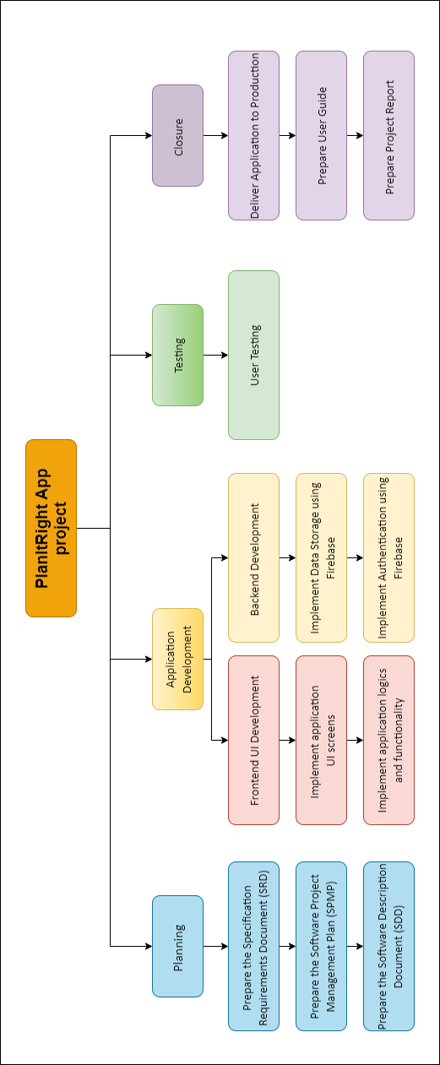

Figure 2 WBS Diagram3.2 Team Member Responsibilities

Table 1 shows member roles and responsibilities for each task or deliverable in this project. R, A, C, I stand for responsible, accountable, consulted and informed respectively.

Table 1 Roles and Responsibilities

|  |  |  |  |
| --- | --- | --- | --- |
| **Task or Deliverable** | **Eric** | **Pokai** | **Harleen** |
| 1.1.1 Specification Requirements Document (SRD) | R, A | R, A | R, A |
| 1.1.2 the Software Project Management Plan (SPMP) | R, A | R, A | R, A |
| 1.1.3 Software Description Document (SDD) | R, A | R, A | R, A |
| 1.2.1.1 Implement application UI screens | R, A | R, A | R, A |
| 1.2.1.2 Implement application logics and functionality | R, A | R, A | I |
| 1.2.2.1 Implement Data Storage using Firebase | R, A | R, A | I |
| 1.3.1 User Testing | A | I | R, A |
| 1.4.1 Deliver Application to Production | R, A | I | I |
| 1.4.2 Prepare User Guide | A | I, C | R, A |
| 1.4.3 Prepare Project Report | A | I, C | R, A |

*R=Responsible, A=Accountable, C=Consulted, I=Informed*

## 3.3 Gantt Chart

Figure 3 shows the Gantt chart of this project. It depicts our project development phases (or milestones), planning schedule, duration, and date of completion of each task.

Please see the following link - <https://onedrive.live.com/redir?resid=3082E2D4756E9604!3512&authkey=!AO4j5Gd44r2nZh4&ithint=file%2cxlsx&e=8p5xod&wdLOR=cD3C25AE1-B3D3-4BA5-982B-4F1720D796CD> for the original excel file of our Gantt chart.

Figure 3 Gantt Chart

# 4 Project Deliverables

## 4.1 Project Report

## 4.2 Software

## 4.3 User Guide

# 5 References

*Introduction to Expo*. (n.d.). Retrieved from Expo: https://docs.expo.dev/

Rawal, K. (2018, Jun 12). *12 Most Popular React Native Development Tools*. Retrieved from codementor: https://www.codementor.io/@kapilrawal/12-most-popular-react-native-development-tools-kf45eu4uh